Requirements and High Level Design (HLD) Document

This document will specify the requirements and the high level design of the desired architecture. This document will help decide how the requirements will be met by the proposed architecture and software.

The outcome of this document is to produce the best and most effective overall design of the application to meet the needs of the specified requirements.

  - Introduction

This user case diagram is an example of a Bloging System. It shows the components of a system used between the shodor staff/administrators to the students. Through this blog system there are certain specifications that can be manipulated my either the staff or students. This will be used to show assigned blog tasks and comments.

  - Subject Matter Experts Agreement List

This section should list all key people involved in the project. It will ensure that all mandatory reviewers have reviewed and agree to the requirements and proposed architecture.

Name | Title/Role | Mandatory  Reviewer (Y/N) | Agreed To
Kaylynn | Project Leader | Y | Create the use case model
Jonathan | Client | Y | Give appropriate requirements
Paris | Programmer | Y | Write brief descriptions about the system
Alex | Programmer | Y | Create the use case model
Whitley | Programmer | Y | Write brief descriptions about the system

  - Requirements

- Create an interface that allows staff and administrator to assign blogs to students
- Only for shodor people
- Shodor staffs are the only people who can create blogs
- Unlimited entries
- Can only be deleted by the staff
- One blog per student
- Shodor people can comment and read
- Students can add entries only if assigned to them

Definition of Objects:

Blog: Journal that is assigned to students by the staff
Entry: Attribute of a blog, which is a post in response to the blog topic
Comment: A different response to the overall entry and blog

Use Case Diagram
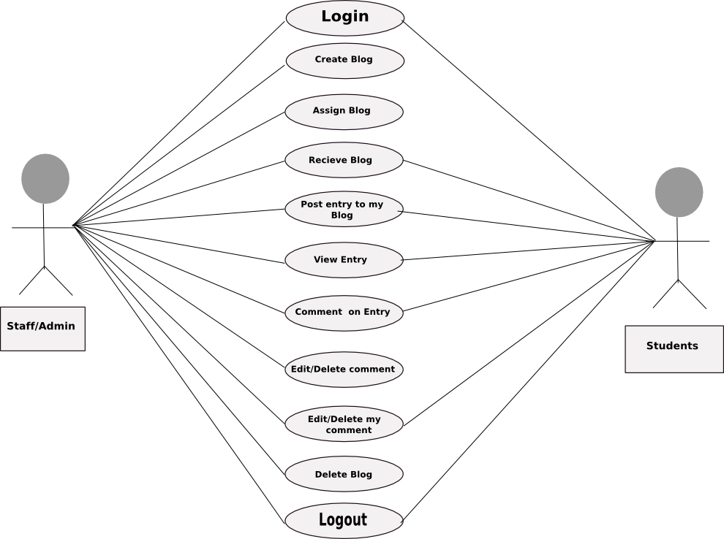

1.3.2 Requirements Table:

Requirements | Description | Comments | Requirement Class | V&V Method
Log in | You must be a student on Staff to use this application |  | Required
Create blog | The administrator (staff) is the only person who can create a blog for themselves or students |  | Required
Assign blog | The administrator can assign blogs to students or themselves or another administrator. Only one blog per student |  | Required
Receive blog | Both students and administrators can receive blogs |  | Required
Post entry to my blog | Once a blog is assigned to a student then they can post and allow readers to view the entry |  | Required
Review entry | When a reader views and reads the blog entry |  | Optional
Comment on entry | Once a reader views and reads the blog they can add a comment |  | Optional
Edit/Delete comment | Administrators can edit or delete another users blog entry or comments, as well as their own blog or comments |  | Optional
Edit/ Delete my comment | The owner of an entry or comment can delete it |  | Optional
Delete blog | The administrators can delete blogs and entries |  | Optional
Log out | The users logged in are able to log our |  | Required

  - Desired Behavior

This program is designed to allow administrators to create read and edit blogs. The program also allows the user to give their personal comments about their blog or a blog they have read.

Note: All feasible options for implementing the specified component should be discussed.

